SECONDARY SCHOOL I: A2 or 13-15
WATCH YOUR TABLE MANNERS!
In the following teaching unit, the students get familiar with dining etiquette. The activity’s aim is to reflect on table manners from different perspectives. The students acquire, understand and use vocabulary related to dining etiquette by exchanging experiences, reading a poem/an article and conducting independent online research.
“Table manners define the meaning of a meal.” (Jonathan Jones, 2011)
“Manners are a sensitive awareness of the feelings of others. If you have that awareness, you have good manners, no matter what fork you use.” (Emily Post, 1872-1960)

PROCEDURES

- Before the lesson starts: Rearrange the desks (4 big tables). Put the material on the tables (see material). Divide the class into four groups.
- Warm-up activity: Have students brainstorm table manners practiced in their homes. Write the findings on the blackboard. Table manners include the following aspects: toast, eating, drinking, seating, body language, conversation, passing food, placement of and using utensils, etc. Let the students evaluate the importance of table manners.
- Let the students work on the tasks. For each task the students have about 15 minutes at their disposal.
- Discuss the findings of the different tasks
- The teacher presents additional information on dining etiquette (for background information see the articles below: “National Geographic”, “The New York Times”, “The Guardian”, “BBC News Magazine”).
- The teacher selects linguistic structures for students to practice based upon what emerged from the tasks.

MATERIAL

- Table 1: Description task 1, dictionary, worksheet A
- Table 2: Description task 2, dictionary, worksheet B
- Table 3: Description task 3, dictionary, worksheet C, two computers
- Table 4: Description task 4, dictionary, worksheet D, plates, spoons, forks, knifes, glasses, napkins (see worksheet D)

BACKGROUND INFORMATION FOR THE TEACHER

National Geographic:
http://theplate.nationalgeographic.com/2014/12/18/table-manners/
The New York Times:
http://www.nytimes.com/1985/10/16/garden/table-manners-a-casualty-of-changing-times.html?pagewanted=1
The Guardian:
http://www.theguardian.com/lifeandstyle/2011/nov/09/history-table-manners-etiquette-beeton
BBC News Magazine:
http://news.bbc.co.uk/2/hi/uk_news/magazine/4551727.stm
MATERIAL FOR THE TEACHER

Task 1: An expat on Swiss table manners
Read the list of Swiss table manners written by an expat journalist and compare the list to your own table manners at home.

Task 2: Table manner poetry
Read the poem “The table manners” aloud. The American author Gelett Burgess (1866-1951) wrote poems about “Goops”. “Goops” are strange baldheaded childlike creatures that do not behave well. Are you sometimes a „Goop“? Think of different examples and add them to the poem (e.g. The Goops they ...).
The poem is from 1900. Do you think table manners change over time?

Task 3: Websites on table manners around the world
Explore websites that focus on table manners. Why do you believe so many guidelines on dining etiquette around the world can be found on the Internet?

Task 4: How do the various settings influence the manners we use?
Brainstorm the different places where you eat a meal (include places in your homes). How do different settings or places influence how you sit, what you say and what is on the table? (Fast-food restaurant, in front of the TV, picnic, a (nice) restaurant, dinner at your grandparent’s house, etc.).
Try to set the table for a formal dinner with the utensils lying on the table. Compare it to the placement on the worksheet. How do you set your table at home?

MATERIAL FOR THE TEACHER
Worksheet A: Swiss table manners explained by an expat

1. | Be on time.
2. | Always wait for everybody to be served before beginning to eat.
3. | All meals are usually started with the words “bon appetit” or “guten Appetit.”
4. | When toasting, chink your glass with everybody at the table and look each person in the eyes before drinking.
5. | Keep your wrists on the table, but never your elbows. Do not place your hands in your lap.
6. | Remember to always say please and thank you.
7. | French bread is always torn rather than cut with a knife.
8. | Lift your forearm from the table while moving the fork to your mouth.
9. | Use your left hand for the fork and the right for your knife and gently push food on your fork.
10. | If you are served cheese as a wheel, it should be cut from the centre into slices (as you would slice a pie).
11. | When finished, put your knife and fork parallel to one another on your place as if they were hands on a clock indicating 5:25. If you don’t do this, your host will serve you more food.
12. | Finish everything you take on your plate. The Swiss do not appreciate waste.
13. | These manners apply to children as young as two.
14. | Additional children rules: Make sure children wash their hands before meals. Children generally must wait to leave the table until everyone is finished.

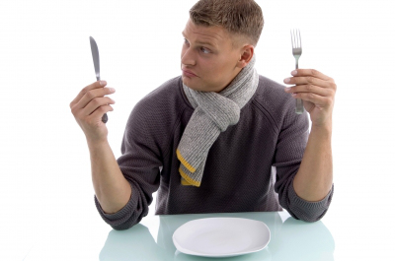
Source: http://www.lifeintheswissalps.com/2010/08/swiss-table-manners-matter.html
A2_Worksheet B

Table Manners
By Gelett Burgess (American poet and humorist, 1866-1951)

The Goops they lick their fingers,
And the Goops they lick their knives;
They spill their broth on the tablecloth --
Oh, they lead disgusting lives!
The Goops they talk while eating,
And loud and fast they chew;

________________________ (your own examples)

And that is why I'm glad that I
Am not a Goop -- Are you?

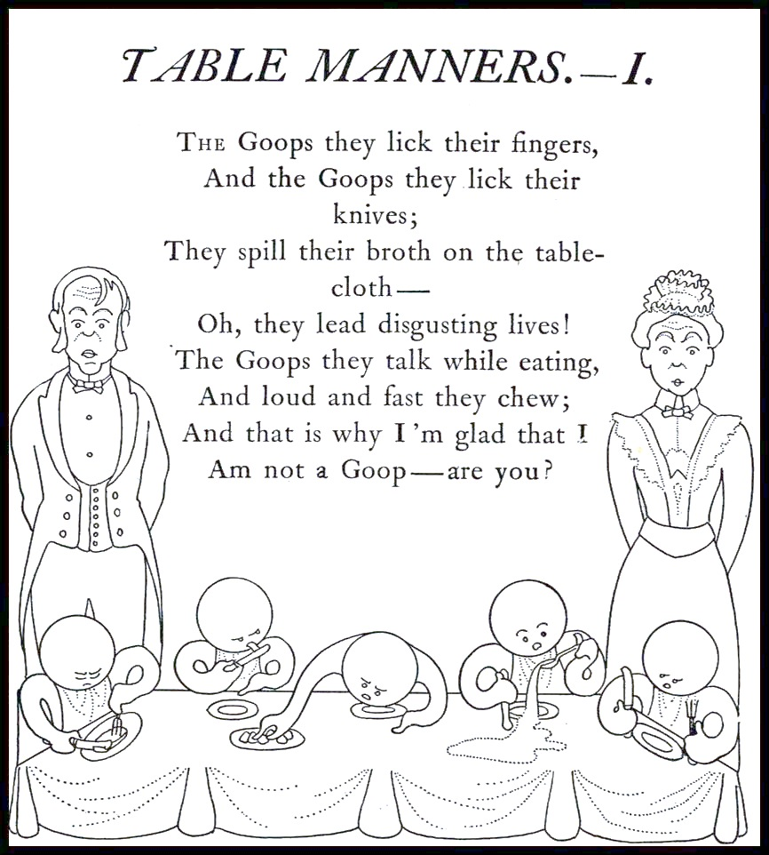

Source: "Table Manners" is reprinted from Goops and How To Be Them, Gelett Burgess. New York: Frederick A. Stokes, 1900.
A2_Worksheet C: Websites for research
http://www.etiquettescholar.com/dining_etiquette/international_dining_etiquette.html

http://www.swissotel.com/promo/etiquette-map/ (see dining)

http://en.wikipedia.org/wiki/Table_manners

http://www.huffingtonpost.com/2013/07/11/dining-etiquette-around-the-world_n_3567015.html

http://www.inc.com/jeff-haden/a-global-traveler-guide-to-dining-etiquette.html

http://etiquette-ny.com/global-dining-etiquette-customs/

http://www.etiquettescholar.com/dining_etiquette/international_dining_etiquette.html

http://www.revbrown.net/etiquette/Global-Dining-Etiquette.html

http://www.kwintessential.co.uk/cultural-services/articles/cross-cultural-dining-etiquette.html

http://edition.cnn.com/2012/02/29/travel/international-food-etiquette-rules/

http://www.thedailymeal.com/table-manners-around-world-slideshow-2013

A2_Worksheet D

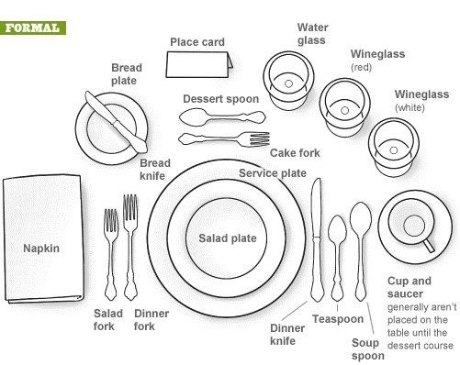

Source: http://www.cernea.net/wpcontent/uploads/2011/12/FormalDiningSetting_4eee9ff3477f1.gif

Highlight that the complexity of table manners in the family does not converge with national stereotypes.

