MATERIAL FOR THE TEACHER
A2_Worksheet A: Swiss table manners explained by an expat

1. | Be on time.
2. | Always wait for everybody to be served before beginning to eat.
3. | All meals are usually started with the words “bon appetit” or “guten Appetit.”
4. | When toasting, chink your glass with everybody at the table and look each person in the eyes before drinking.
5. | Keep your wrists on the table, but never your elbows. Do not place your hands in your lap.
6. | Remember to always say please and thank you.
7. | French bread is always torn rather than cut with a knife.
8. | Lift your forearm from the table while moving the fork to your mouth.
9. | Use your left hand for the fork and the right for your knife and gently push food on your fork.
10. | If you are served cheese as a wheel, it should be cut from the centre into slices (as you would slice a pie).
11. | When finished, put your knife and fork parallel to one another on your place as if they were hands on a clock indicating 5:25. If you don’t do this, your host will serve you more food.
12. | Finish everything you take on your plate. The Swiss do not appreciate waste.
13. | These manners apply to children as young as two.
14. | Additional children rules: Make sure children wash their hands before meals. Children generally must wait to leave the table until everyone is finished.

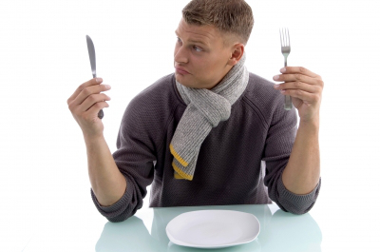
Source: http://www.lifeintheswissalps.com/2010/08/swiss-table-manners-matter.html

