A2_Worksheet B

Table Manners
By Gelett Burgess (American poet and humorist, 1866-1951)

The Goops they lick their fingers,
And the Goops they lick their knives;
They spill their broth on the tablecloth --
Oh, they lead disgusting lives!
The Goops they talk while eating,
And loud and fast they chew;

________________________ (your own examples)

And that is why I'm glad that I
Am not a Goop -- Are you?

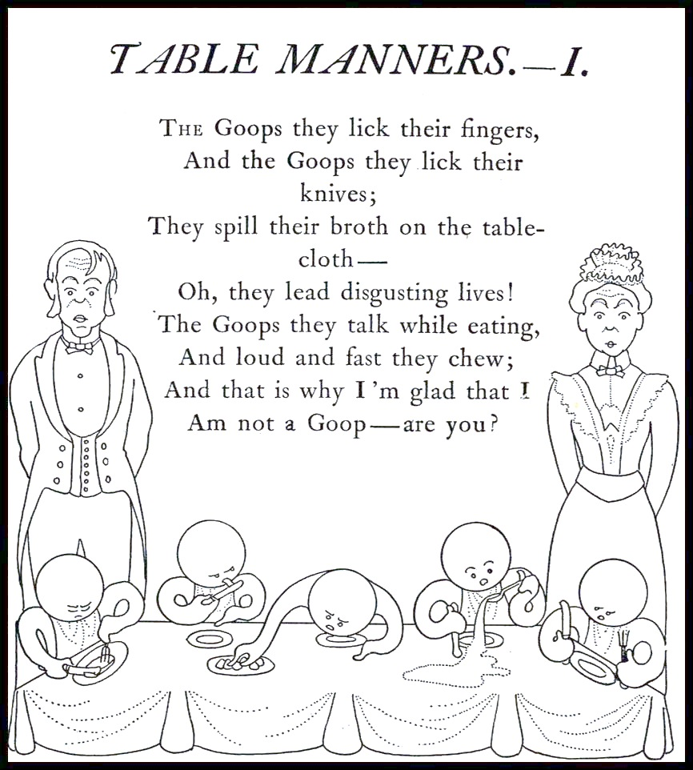

Source: "Table Manners" is reprinted from Goops and How To Be Them, Gelett Burgess. New York: Frederick A. Stokes, 1900.

