A2_Worksheet D

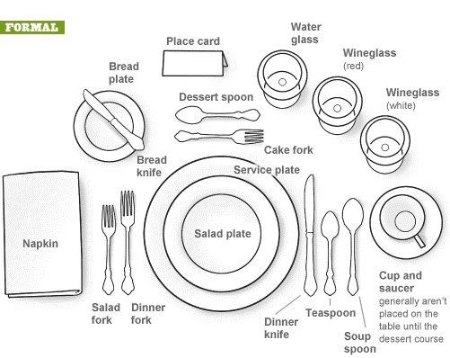

Source: http://www.cernea.net/wpcontent/uploads/2011/12/FormalDiningSetting_4eee9ff3477f1.gif

