IT’S MEALTIME!

APPROACHING FOOD AROUND THE PLANET WITH CLIL ACTIVITIES FOR EFL CLASSROOMS

Martina Zimmermann, Simone Ries, Anna Häfliger & Gustav Arnold, PH Luzern
Primary school: A0 or 9-11
Primary school: A1 or 10-12
Secondary school I: A2 or 13-15
Secondary school II: B2/C1 16-18

“Content and Language Integrated Learning” (CLIL) als Oberbegriff für Lehrkontexte, in welchen Fachinhalte in einer anderen Sprache vermittelt werden, hat in den letzten Jahren zunehmend an Bedeutung gewonnen (Bentley, 2009; Marsh, 1994). CLIL birgt u.a. die Vorteile, mehr Zeit für Input in der Zielsprache zu haben (vgl. Smit & Dalton-Puffer, 2007), dem Sprachenlernen aufgrund des inhaltlichen Fokus einen echten Sinn zu geben und kulturelle Inhalte über die Einzelsprache hinaus einbeziehen zu können. Als Herausforderungen, die CLIL mit sich bringt, werden u.a. schulpolitische Bedingungen, der Mangel an Know-How der Lehrpersonen im Fach oder in der Fremdsprachendidaktik und das fehlende passende Material genannt .
Die vorliegende didaktische Anlage zum Thema “Food Around The Planet” will dazu beitragen, das Repertoire von Lehrpersonen zu erweitern, die in ihrem Englischlektionen CLIL-Elemente einbauen wollen. Es werden konkrete Vorschläge gemacht, wie ein Thema im Fremdsprachenunterricht Englisch von der Primar- bis zur Sekundarschule II im Sinne von CLIL alters- und sprachniveauadäquat umgesetzt werden kann. Diese laden dazu ein, über eigene und fremde Essgewohnheiten und -praktiken nachzudenken, die über vereinfachende, nationale Stereotypen hinausgehen und der alltäglichen kulinarischen Diversität (z.B. innerhalb einer Familie) gerecht werden. Inspiriert sind die Materialien teilweise von der Publikation “Hungry Planet: What the world eats” der beiden Autoren Menzel & D’Aluisio (2005). Das Paar hat Familien auf der ganzen Welt besucht und porträtiert. Daraus ist ein imposanter Fotoband entstanden, in dem deren wöchentliche Ess- und Konsumgewohnheiten dargestellt werden. Die Mehrheit der folgenden Vorschläge basiert auf Porträts und dazugehörigen Texten, die online zugänglich sind. Das Buch „Hungry Planet“ ist zudem in fast jeder Bibliothek erhältlich.
Das durchaus erweiterbare Mind-Map (Fig. 1) zeigt die Vielfalt der Aspekte auf, die sich im Zusammenhang mit dem gewählten Thema anbieten. Im Bereich "Culture" wurden vier davon aufgegriffen und alters- und sprachniveaugerecht aufbereitet. Die Vorschläge sind als Word-Dokumente auf babylonia.ch downloadbar und können nach Bedarf angepasst und weiterentwickelt werden. Die am Schluss aufgeführten Ressourcen zeigen auf, dass das Thema gegebenenfalls ausbaubar ist und bereits ein grosser Materialfundus besteht.

Fig. 1 Thematische Übersicht
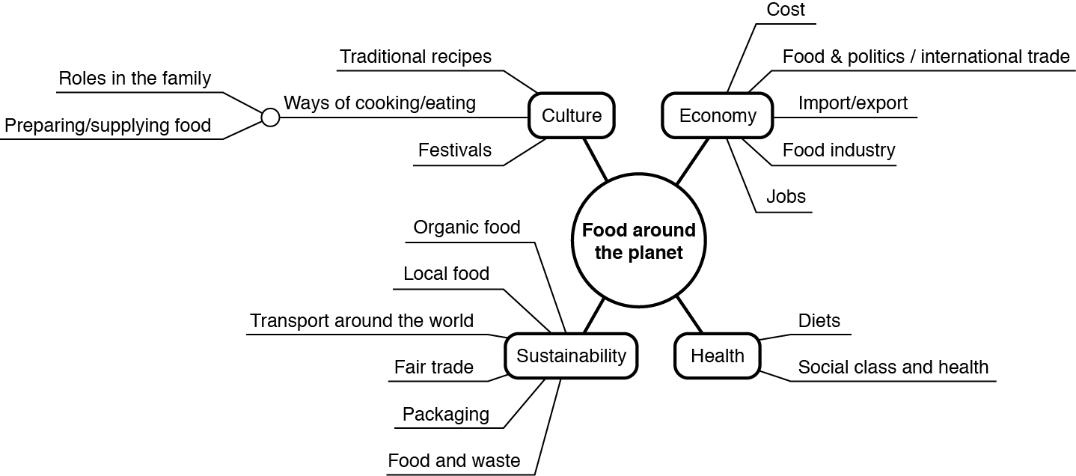
Die Aktivitäten zu „Food around the planet“ wurden lehrmittelunabhängig entwickelt. Die meisten Lehrmittel, die im Englischunterricht verwendet werden, bieten aber Anknüpfungspunkte (z.B. Young World 1, Unit 3 „Apples & Crisps; Young World 1, Unit 4 „The way we live“, New Inspiration 2, Unit 5 „Could I borrow some money?“).

Bibliographie
Arnet-Clark, I., Lanz, C., Koller-Grimm, U., Hartmann, F., Sigel, B., Schüpfer, I., & Stampfi-Vienny, C. (2005). Young World 1. Klett Verlag: Switzerland.

Bentley, K. (2009). Primary Curriculum Box. CLIL lessons and activities for younger learners. Cambridge: Cambridge University Press.

Garton-Sprenger, J. & Prowse, Ph. (2011). New Inspiration 2. Macmillan Education: Oxford.

Marsh, D. (1994). Bilingual Education & Content and Language Integrated Learning. Paris: International Association for Cross-cultural Communication, Language Teaching in the Member States of the European Union (Lingua), University of Sorbonne.

Massler, U. & Stotz, D. (Hg.) (2013). CLIL in der Primarstufe. Ein theoriebasierter Leitfaden für die Entwicklung von Aufgaben für Unterricht und Beurteilung. Trier: WVT.

Menzel, P. & D’Aluisio, F. (2005). Hungry Planet: What the World Eats. Napa, CA: Material World Press.

Naves, T. (2002). What Are the Characteristics of Successful CLIL Programmes? In: TIE-CLIL Professional Development Course. Ed. G. Langé. Milan: M.I.U.R.: 91-94.

Niemeier, S. (2000). Bilingualismus und «bilinguale» Bildungsgänge aus kognitiv-linguistischer Sicht. In G. Bach & S. Niemeier (Hrsg.), Bilingualer Unterricht. Grundlagen, Methoden, Praxis, Perspektiven, 5, (S. 27–49). Frankfurt am Main: Peter Lang.

Smit, U. & Dalton-Puffer, C. (eds.) (2007). Current research on CLIL 2. VIEWS (Vienna English Working Papers), 16/3.

Zusätzliche Links mit Materialien für Lehrpersonen
Text
- http://www.eusa.org/siteresources/data/files/pg_hungryplanet.pdf

Bilder
- http://catalog.socialstudies.com/pdf/ZP384Psample.pdf
- http://time.com/8515/hungry-planet-what-the-world-eats/
- http://www.demilked.com/what-the-world-eats/

B2
- Aktivitäten zum Thema Production, Consumption & Waste
https://sites.google.com/site/msvasichscourses/media-studies/hungry-planet-production-consumption-waste
- Ted-Talk von Peter Menzel (14 Minuten): http://www.tedmed.com/talks/show?id=7191
- Interview mit Peter Menzel und Faith D’Aluisio: http://photo.net/photographer-interviews/peter-menzel/
- Artist’s talk mit Peter Menzel and Faith D’Aluisio (70 Minuten): https://www.youtube.com/watch?v=RXCxwOgjJ4Y

Martina Zimmermann, Simone Ries, Anna Häfliger und Gustav Arnold dozieren an der Pädagogischen Hochschule in Luzern und bringen Lehrerfahrung auf verschiedenen Stufen mit. Mehr Informationen unter www.phlu.ch.

PRIMARY SCHOOL: A0 or 9-11

IT’S MEALTIME!
The sequence’s overall purpose is to have the children explore what families in other parts of the world (Turkey, Italy, USA) eat, with special interest for their favourite foods. Finally they learn about the families’ (traditional) meal and how it is prepared.

In the introduction to the sequence (1.) the teacher gives a detailed presentation of the three families using pictures and background given. The questions listed (2. – 4.) can be dealt with either in short sequences or else be extended to a series of lessons.

PROCEDURES

- Teacher presents 3 families: from Turkey, USA California, Italy Sicily
- Pictures taken from:
http://www.viralnova.com/different-country-groceries/
- Text: see background information sheet. Source: http://www.eusa.org/siteresources/data/files/pg_hungryplanet.pdf
- Where does the family live?
- Have learners check with help of the world map/globe.
- Mark with a pin, compare the distances to Switzerland.
- Who knows someone in Italy, Turkey, USA?
- Who belongs to the family?
- Learners recall from the teacher’s presentation, who the family members and what their names are.
- Which family is my favourite? Why?
- Learners choose their favourite family from the choice of pictures (Choice can be extended with the 3 pictures used for 5/6 grade activities: Mali, Bosnia and Herzegovina, Ecuador). They present their choice: My favourite family lives in........................I like them best because.........................................................
- Children prepare in pairs what they want to say, teacher provides the language support needed.
- What do they eat? Which foods do I know? Do I not know?
- Children work in groups with a chosen/assigned family picture collecting the food vocabulary displayed. They sort the foods into ‚food I know’/‚food I don’t know’
- What is their favourite meal?
- In groups learners work out their picture-family’s favourite food/meal
from text
- They compare their findings with their own favourite foods.
- They find out about the ‚family meal’ from text.
- They read and understand the ‚family meal’ recipe from text and copy
it onto the poster.
- Comparison of favourite foods, family meal and - recipe are displayed in a group poster.
A0_MATERIAL FOR THE TEACHER
Family Portraits (background information for the teacher’s presentation)

The Çeliks of Istanbul, Turkey: The Çelik family gathers in the main room of their three-room apartment in Istanbul. Melahat Çelik (center left) and her husband Mêhmêt met through an arranged marriage, and Melahat’s mother Habibe Fatma Kose (far right) has lived with them for most of their married life. In addition to cooking for her family, Melahat also cooks and cleans for six other families during the week. On nights when she works late, she relies on her mother and her sister—who lives in the same building—to help take care of the children, Aykut, Semra, and Mêtin (front to back, at left). The family uses the living room as its primary gathering space. A market vendor prepares to haggle with the day’s customers as he displays wedges of pumpkin squash. While such markets have largely disappeared from the commercial landscape of industrialized nations like the United States, they remain an integral part of the food business in developing nations. Melahat and her son Aykut buy eggs at an open-air market near one of the homes where she works. These daily markets are still the primary food shopping source in Turkey, and vendors like the egg salesman move from one neighborhood market to another during the week. Varying their days of operation allows the markets to avoid competition with each other—no two neighboring markets operate on the same day.
United States of America: The United States epitomizes the Good, the Bad, and the Ugly food habits of the modern, industrialized nation. A trip to any supermarket or survey of local restaurants quickly reveals the Good—the abundance, variety, availability, and relatively low cost of food in this country. We can have what we want virtually any time of day and increasingly independent of season, climate or geography. Our food preferences and our food supply are going global, thanks to efficient economic access, our rich multicultural heritage, the increasing ease of travel abroad. and a record influx of immigrants into the United States in the late 20th century. The Bad and the Ugly of this abundance are the refined and chemically engineered food products along with their fast food meals. We want it when we want it, which, more often than not, means long shelf lives, pre-assembly and pre-cooking. Such foodstuffs have cultivated our taste for fat, starch, sugar, and salt. In tandem with the low levels of calorie burning born of our car culture, predominantly sedentary jobs, and our over-scheduled lives, this abundance has led to record levels of obesity, diabetes, and stress—in short, Americans are on the road to becoming the unhealthiest citizens on the planet. The three families seen here bear witness to the challenges such abundance creates. The Cavens of California epitomize parental quandaries about their children’s health also registered by the other two families: how to balance out their children’s wants with their nutritional needs and how to offset the lure of the TV with safe outdoor play. At the same time we see them striving to maximize the Good— the year-round variety of fresh foods and the organic options of such abundance.
The Cavens of California: In the Drive-through. After grocery shopping, Craig Caven of American Canyon, California, stops at the drive- through window of a local McDonald’s to pick up Happy Meals for his two children. Although this scene is a common occurrence for most American households, the Cavens are not regular customers of fast food. Craig and his wife Regan try to set a good example. They generally do most of their cooking at home, and take the kids out for a Happy Meal treat just a few times each month.
The Manzos of Sicily, Italy: The Capo market area of Palermo, Italy stirs to life before dawn and thus begins Giuseppe Manzo’s day on the same street where his father used to sell ice for a living. Giuseppe, a fishmonger, works just downstairs and across the street at a large storefront fish market owned by two brothers. Giuseppe’s wife, Pietra Marretta, is up as well, getting their two older boys, Pietro and Domenico, ready for school.
Although fish is actually an infrequent offering at the Manzo’s own table (Pietra doesn’t like it), the family’s everyday life still revolves around the fishmarket. The boys stop by their father’s shop for money and then race across the street to a small shop to buy candy and snacks and a juice box each. Meanwhile Giuseppe tosses buckets of ice into shallow bins and his fellow workers lay out the day’s catch. He often stays there for lunch, enjoying seafood salad between serving customers. Unlike most of western Europe, large supermarkets have not yet overrun Sicily. The island’s limited purchasing power makes it an unappealing site, so traditional shopping areas – like this fish market – still serve most customers.
Favourite foods and family meals
- The Çeliks of Istanbul, Turkey
Favorite Foods: Melahat's Puf Böregi - Puffed Pastries.

- The Manzo family of Sicily, Italy:
Favorite foods: fish, pasta with ragu, hot dogs, frozen fish sticks.
The Manzos’ family meal: Pasta C’anciuova – Pasta with Anchovies

- The Caven family of California, USA
Favorite foods: beef stew, berry yogurt sundae, clam chowder, ice cream.
The Cavens’ family meal: Beef Stew

The Çeliks’ family meal: Melahat’s Puf Böregi (Puffed Pastries)
250 g flour  180 ml water  1 egg  1 tablespoon olive oil  80 g melted butter  250 g feta cheese, grated  250 – 325 ml vegetable oil | - To make the dough put together flour, water, egg and olive oil. Rest dough for 15 minutes before you cut it into 5 equal pieces.  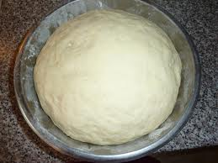  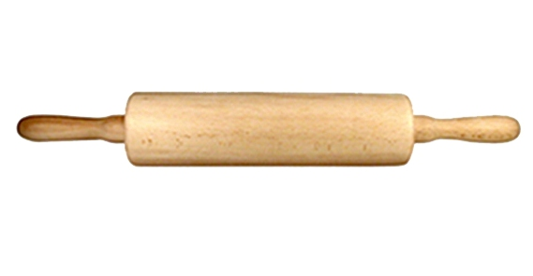  - Roll the five pieces flat with a rolling pin. Spread melted butter on both sides and put them on top of each other. Let them stand for 30 minutes.  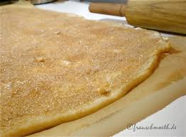  - Roll out dough as thin as possible into a large disk. On half the disk place small portions of feta cheese.  - Fold empty half of disk over filled half. Cut out a semi circle in dough with a saucer. Press around edges with fingers to close tightly in half-moon shapes.  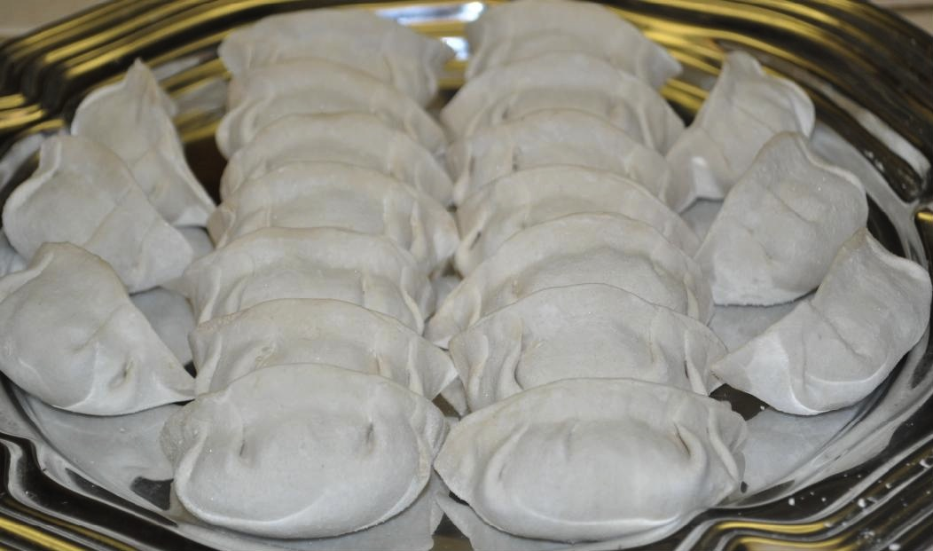  - Fry dumplings in oil and serve.  See also: https://www.youtube.com/watch?v=w9sYngWHKUw
More words
to rest | ruhen
to cut | schneiden
to fry | braten
equal pieces | gleich grosse Stücke
to spread | streuen
melted | geschmolzen
disk | Scheibe
to fold | falten
semi-circle | Halbkreis

The Manzo’s family meal: Pasta with Anchovies (Pasta C’anciuova)
4 cloves garlic, minced  2 tablespoons olive oil  25 g anchovies  250 g tomato puree  250 ml water  50 g golden raisins  6 tablespoons pine nuts  2 teaspoons salt  2 teaspoons pepper  2 teaspoons sugar  175 g bread crumbs  625 g spaghetti | - Cook garlic in olive oil over medium heat for 5 minutes, until garlic is golden brown but not burned. Add anchovies until they begin to soften and break apart. Add tomato puree, water, raisins, pine nuts, salt, pepper and sugar.  - In a separate pan, brown bread crumbs with rest of olive oil. Add more oil if necessary to prevent burning, but mix well and don’t soak crumbs in oil.  - Bring salted water to a boil in a large pot. Add pasta and boil until cooked al dente.  - Drain pasta and mix with sauce. Sprinkle with bread crumbs and serve.

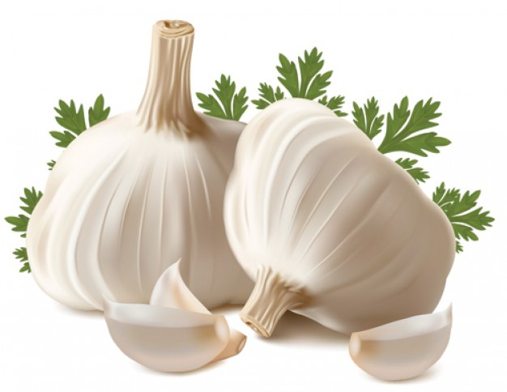 | 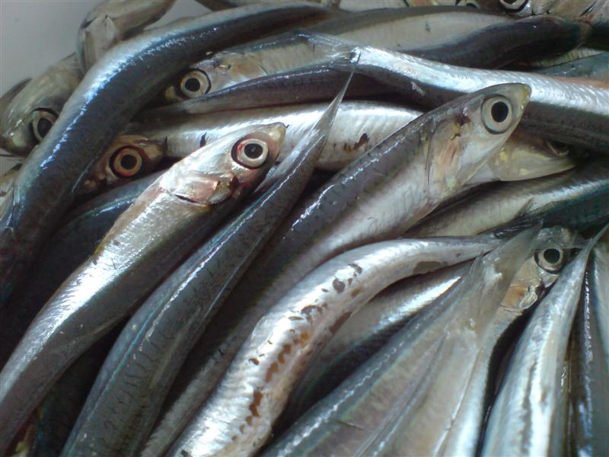 | 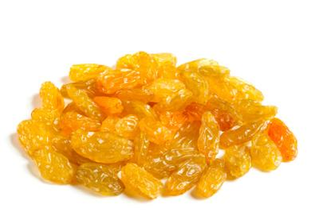 | 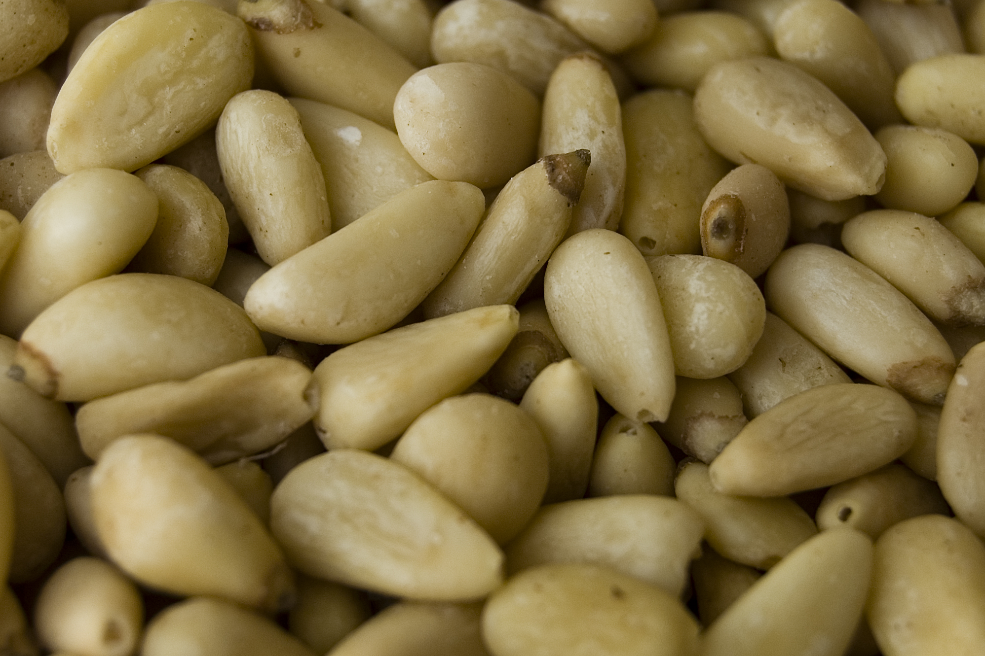 | 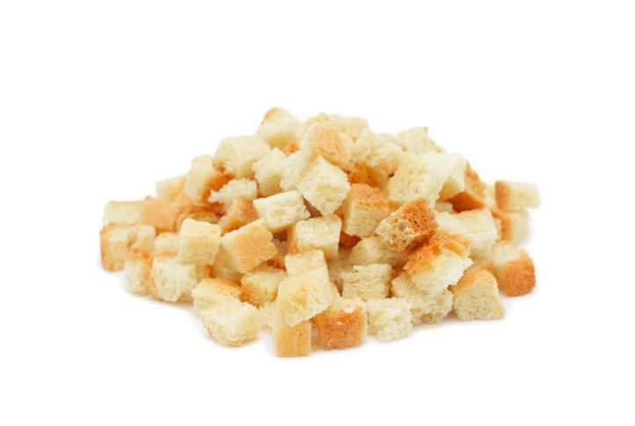
garlic | anchovies | golden raisins | pine nuts | bread crumbs
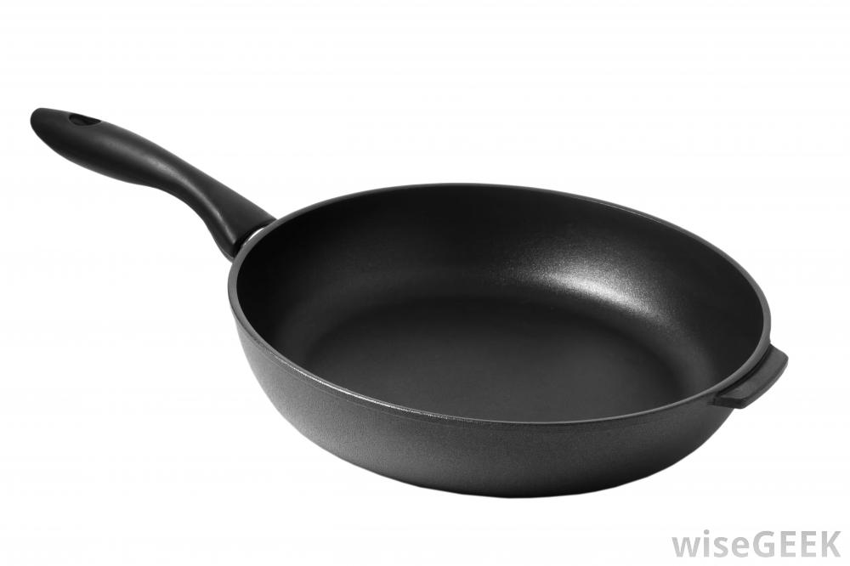 |  |  | 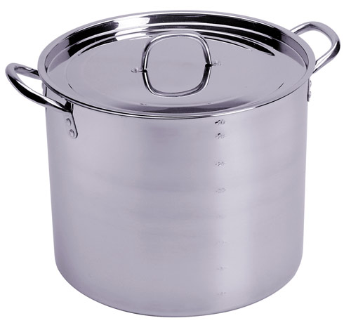
pan |  |  | pot

More Words
clove | Zehe (Knoblauch)
minced | gehackt
to brown | bräunen
to prevent | verhindern
to burn | verbrennen
to soak | durchtränken
to boil | kochen, sieden
to drain | abtropfen
to spread | streuen
medium heat | Mittelhitze

The Cavens’ family meal: Beef Stew
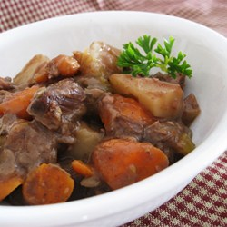  900 g stew meat, extra lean, cut into 2 cm chunks  1 large onion, peeled and cut into eighths (1/8)  1 – 2 tablespoons vegetable oil  5 dl water  2,5 dl canned tomato sauce  1 clove garlic, minced  4 tablespoons fresh parsley, chopped  ¼ teaspoon basil, dried  ¼ teaspoon marjoram, dried  ¼ teaspoon oregano, dried  ¼ teaspoon freshly ground black pepper  ¼ teaspoon rosemary, dried  ¼ teaspoon sage, dried  ¼ teaspoon salt  ¼ teaspoon thyme, dried  3 large potatoes, with skins, cut into eighths (1/8)  2 carrots, cut into bite-size pieces  2 stalks celery, chopped | - In a large pot, brown beef and onions in oil.  - Add water, tomato sauce, garlic, parsley and all spices. Bring to boil, then lower heat, cover, and simmer for 1 hour.  - Add potatoes, carrots and celery. Simmer covered until tender ( 30 - 60 minutes)  - Serve with good, crusty bread.
 | Some words
 | boil | kochen, sieden
 | lower heat | Hitze reduzieren
 | cover | zudecken
 | simmer | köcheln
 | tender | zart
See also: https://www.youtube.com/watch?v=wrTKGoFxkM8
Recipe shows procedure slightly differently.

More words
lean | mager
peeled | geschält
cut | geschnitten
minced | gehackt
chopped | gehäckselt
canned tomato sauce | Tomatensauce aus der Dose
clove garlic | Knoblauchzehe
parsley | Petersilie
sage | Salbei
skin | Schale (Kartoffel)
bite-sized pieces | mundgrosse Stücke
stalks celery | Stangensellerie

PRIMARY SCHOOL: A1 or 10-12
DIFFERENT FAMILIES AND THEIR FOOD HABITS
In the following teaching unit, the pupils get familiar with food habits of different families and compare them within the class and with their own family. The activity’s aim is to get to know other habits in other contexts rather than to look at them from a moral perspective focusing e.g. on world hunger.

PROCEDURES
- The teacher presents three different families on the basis of pictures and textual material by explaining what, when and where they eat.
- The teacher introduces a grid enabling the pupils to collect data during one week. Their task is to report their own diet during a week and write down which meal, what kind of food and where they eat with their family (see worksheet A).
- A week later, they compare their results within the class and with one of the families presented in the introduction (Family Natomo from Mali, Family Dudo from Bosnia and Herzegovina or Family Ayme from Ecuador). A Venn diagram (see worksheet B) guides them how to do their comparison focusing on one meal (breakfast, lunch or dinner). After some time for planning, they present their comparison to each other. An adaptable language support (see sheet C) is provided facilitating the comparison.
- Based on the level of the pupils, a follow-up might be helpful to introduce or consolidate specific linguistic structures and raise the consciousness for them. The following are suggestions for potential language activities for different levels:
- Present tense 3rd person singular: he, she, it (e.g. the family eats outside, we eat inside)
- Rules for adding "s" with verbs ending with "s", "ch", "sh", "x" or "z" (they mix he mixes millet porridge with tamarind juice)
- Expanding vocabulary related to the topic: e.g. cooking and or kitchen tools (mixing, stirring, ladle chopping board, firewood…), living (living room, open fireplace, tent, etc.)
- Introduction of comparative and/or superlative in English (e.g. simple, simpler, the simplest)
- Comparison (e.g. They eat more potatoes than my family.)
- Quantifiers (e.g. lots of, a small number of, etc.)

MATERIAL

- Material for the teacher: Texts and portraits of three different families
- Worksheet A: Weekly eating habits of your family (preferably to be printed on A3)
- Worksheet B: Comparison of eating habits of your own family with family X (on the basis of Venn diagram preferably to be printed on A3)
- Worksheet C: Language support
MATERIAL FOR THE TEACHER
1. Family Natomo, Mali
Picture http://time.com/8515/hungry-planet-what-the-world-eats/ Number 23
Soumana Natomo and his family gather on the rooftop of their home in the village ofKouakourou on the Niger River. Their Muslim faith allows husbands to take up to four wives, provided they are supported and treated equally. Natomo (center, in blue) has two wives seated at his sides: Fatoumata Toure (right) and Pama Kondo (left) and a total of nine children. Soumana’s sister-in-law Kadia (left of Pama) and her two children are living with Natomo’s family while her husband works in Ivory Coast. The sparse selection of foods represented in their week’s worth reflects the family’s low-tech existence. They live in a complex of mud-brick houses lined with high-walled courtyards. Their windowless home is minimally furnished with sleeping mats and possibly a cushion or stool. They have no electricity and their water comes from community wells or the river.
Breakfast in Soumana Natomo’s large household begins before sunrise when his second wife, Fatouma Toure, starts the morning fire in the courtyard of first wife Pama Kondo’s home. The Muslim grain trader begins his day with prayer as the children awaken in both of his houses (each wife has her own). Roosters provide accompaniment to the sound of millet being winnowed before breakfast. Water is poured over the grain then sloshed back and forth as debris is picked out by hand. The millet porridge is then cooked in water and tamarind juice over a fire until thickened. The combined family of 15 (including Natomo’s sister-in-law and three children) eats from the cooking pot. Some mornings the family has a rice porridge cooked with sour milk. Other mornings breakfast is a fried cake called ngome made of pounded millet or corn, with flour, oil, and salt. Co-wife Fatoumata Toure sells these in the weekend market and also on the street outside her house. Lunch is normally a stew of oil, tomato, onion, salt, and water from the community wells, and dried fish if there is enough money. The stew is eaten with white smoked rice. Dinner is a dish called to, a traditional mixture of millet or corn mixed with water; and okra soup made with hot red peppers, salt, and bouillon-type cubes. The children wash the few dishes used in the nearby Niger River.
Twelve-year-old Fourou glances up from a breakfast of thin rice porridge cooked with sour milk. Natomo’s two wives alternate cooking at Pama’s home, where all meals are prepared and eaten. Like most of their neighbors, Natomo and his family eat outdoors on low stools around a communal pot. Cooking, eating, and daily life in general take place outside in the family’s courtyard.
Further information in Menzel & D’Aluisio (2005: 207-217)

2. Family Dudo, Bosnia and Herzegovina
Picture: http://www.demilked.com/what-the-world-eats/
The Dudo family stands in the kitchen/dining room of their home in Sarajevo with one week’s worth of food. Ensada (left), Rasim (right), and their children Ibrahim, Emina, and Amila remained in Sarajevo during the violent civil war of the early 1990s. Although they struggled to survive and put food on their table – Rasim’s father died at the front – they were luckier than most Sarajevans. Living in the foothills above the city, they had their own well for water, fruit trees, a vegetable garden, and a milk cow. Today they still live in the same two-family home that was built by Rasim’s father before the conflict.
Throughout war-ravaged Bosnia in the early 1990’s, the Dudo family struggled along with the rest of Sarajevo to put food on the table. But while most of the city dwellers had to brave sniper’s bullets to stand in line for water rations, the Dudo family drew water from a well they had dug before the war and shared their good fortune with neighbors.
Life is much easier today for Sarajevans although most are still struggling to regain their pre-war financial security. Ensada, who works for a Muslim aid organization, and Rasim, a taxi driver, have three children; and all converge on the house for lunch, typically the most important meal of the day. Ensada makes stewed chicken, or bosanski lonac – a meat and vegetable stew usually made with mutton. The Dudos are Muslim and therefore eat no pork. For lunch they also have salad. Dinner might include lunch leftovers along with ayjar, a preserved eggplant and red pepper spread, on crusty slices of bread.
Ensada bakes on the weekends. Rahat lokum, nutty jellied chews and halva, a confection tradition – all made from honey and ground sesam seeds are her specialties.
For further information see Menzel & D’Aluisio (2005: 47-51)

3. Family Ayme, Ecuador
Picture: http://time.com/8515/hungry-planet-what-the-world-eats/ Number 12
Wearing traditional felt hats, the members of the Ayme family gather around their week’s worth of food in their kitchen house (they have sleeping house too) in Tingo, Ecuador, a village in the central Andes. They grow much of their food—potatoes, oca (a root vegetable), corn, wheat, broad beans, and onions—in fields located at 11,000 feet above sea level. A few times per year they eat chicken and cuy (guinea pig); otherwise, milk from family cows is their primary source of animal protein. To purchase additional food, they rely on the occasional sale of a sheep from their flock of 50, and husband Orlando’s salary of $50 per month as Tingo’s representative to a national political party. Even so, money is tight.
The windstorms that whip through the Andean mountains during the dry months of September and October render even the shortest walk a trial. Still, subsistence farmers rely on a good harvest, so no matter the weather, the Ayme family must tend to its fields. Stiff winds deliver a spray of dirt against the tin roof of the family’s earth-walled sleeping room throughout the night. The young couple and their children awaken early— some prepare for school and others pull on their clothes to tend the family’s sheep. Ermalinda is still breast-feeding her youngest son, so she bundles him closely to her while she stoops to make the cooking fire. She puts water on to boil that daughter Nataly, 8, has fetched from a spring a short walk away. Breakfast is dry parched corn and tiny roasted potatoes eaten from a communal bowl on the floor, a bit of panela (brown sugar), and hot tea. Orlando and his two older sons walk to their potato field one-half mile away, to ready it for the next potato crop. Most of the year the family plants root crops that will not get damaged in the fierce winds. They plant grains only during the rainy season. Daughter Jessica, 10, is the family sheepherder. The sheep are never eaten by the family. They are raised to be sold during the periods when there is nothing to harvest and all of their food is purchased at a distant weekly market. Their land is less fertile than that further down the mountain “but it’s too expensive down there,” says Orlando. Instead, he is paid a stipend by the government to represent the indigenous interests of his small village. Women in the area earn extra money by weaving for the local cooperative, and young and old alike take part in community works projects called mingas.
For dinner, the Aymes have a potato soup with onions. For lunch, they would have soups too, and sometimes, they eat pea-flour porridge with potatoes.
For further information see Menzel & D’Aluisio (2005: 107-116)
Source of the different texts: http://www.eusa.org/siteresources/data/files/pg_hungryplanet.pdf
Worksheet A: Weekly eating habits of your family

Name: _______________ Amount of family members: _____________

Report during one week which meal, what kind of food and where your family eats!

Meal | Monday | where | Tuesday | where | Wednesday | where | Thursday | where | Friday | where | Saturday | where | Sunday | where
e.g.  breakfast | - Avocado with yoghurt  - Bread with marmalade | At the kitchen table

Worksheet B: Comparison of eating habits at ______________ (e.g. breakfast, lunch or dinner)
What does family ______________ eat? Where
What does your family eat? Where?
What do both families eat?
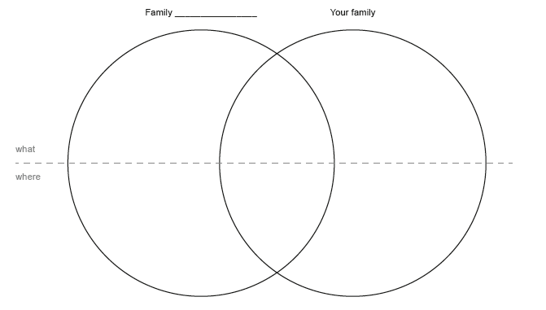

Worksheet C: Language support
Where?
Meals
breakfast = Frühstück
brunch = Brunch
lunch = Mittagessen
dinner = Abendessen
snack = Zwischenmahlzeit
afternoon snack = Zvieri

Food
broad beans = Saubohnen  chicken = Huhn, Poulet  corn = Mais  dried fish = getrockneter Fisch  eggplant = Aubergine  guinea pig = Meerschweinchen  meat = Fleisch  millet = Hirse  mutton = Lammfleisch  oil = Öl  okra = Okra  onion = Zwiebel  pea-flour = Erbsenmehl | pork = Schwein  porridge = Haferbrei  potatoes = Kartoffeln  red pepper = rote Peperoni  salad = Salat  slice of bread = Brotscheibe  soup = Suppe  sour milk = Sauermilch  tamarind juice = Tamarindensaft  tomato = Tomate  vegetable = Gemüse  wheat = Weizen
Where
outside = draussen
inside = drinnen
on the floor = auf dem Boden
at the table = am Tisch
the kitchen = die Küche
dining room = das Esszimmer
Comparison
Example “breakfast”:
For breakfast, my family eats bread, cornflakes and yoghurt.
We eat in the kitchen at the table.

Family __________ eats millet porridge for breakfast.
They eat outside on the floor.

SECONDARY SCHOOL I: A2 or 13-15
WATCH YOUR TABLE MANNERS!
In the following teaching unit, the students get familiar with dining etiquette. The activity’s aim is to reflect on table manners from different perspectives. The students acquire, understand and use vocabulary related to dining etiquette by exchanging experiences, reading a poem/an article and conducting independent online research.
“Table manners define the meaning of a meal.” (Jonathan Jones, 2011)
“Manners are a sensitive awareness of the feelings of others. If you have that awareness, you have good manners, no matter what fork you use.” (Emily Post, 1872-1960)

PROCEDURES

- Before the lesson starts: Rearrange the desks (4 big tables). Put the material on the tables (see material). Divide the class into four groups.
- Warm-up activity: Have students brainstorm table manners practiced in their homes. Write the findings on the blackboard. Table manners include the following aspects: toast, eating, drinking, seating, body language, conversation, passing food, placement of and using utensils, etc. Let the students evaluate the importance of table manners.
- Let the students work on the tasks. For each task the students have about 15 minutes at their disposal.
- Discuss the findings of the different tasks
- The teacher presents additional information on dining etiquette (for background information see the articles below: “National Geographic”, “The New York Times”, “The Guardian”, “BBC News Magazine”).
- The teacher selects linguistic structures for students to practice based upon what emerged from the tasks.

MATERIAL

- Table 1: Description task 1, dictionary, worksheet A
- Table 2: Description task 2, dictionary, worksheet B
- Table 3: Description task 3, dictionary, worksheet C, two computers
- Table 4: Description task 4, dictionary, worksheet D, plates, spoons, forks, knifes, glasses, napkins (see worksheet D)

BACKGROUND INFORMATION FOR THE TEACHER

National Geographic:
http://theplate.nationalgeographic.com/2014/12/18/table-manners/
The New York Times:
http://www.nytimes.com/1985/10/16/garden/table-manners-a-casualty-of-changing-times.html?pagewanted=1
The Guardian:
http://www.theguardian.com/lifeandstyle/2011/nov/09/history-table-manners-etiquette-beeton
BBC News Magazine:
http://news.bbc.co.uk/2/hi/uk_news/magazine/4551727.stm
MATERIAL FOR THE TEACHER

Task 1: An expat on Swiss table manners
Read the list of Swiss table manners written by an expat journalist and compare the list to your own table manners at home.

Task 2: Table manner poetry
Read the poem “The table manners” aloud. The American author Gelett Burgess (1866-1951) wrote poems about “Goops”. “Goops” are strange baldheaded childlike creatures that do not behave well. Are you sometimes a „Goop“? Think of different examples and add them to the poem (e.g. The Goops they ...).
The poem is from 1900. Do you think table manners change over time?

Task 3: Websites on table manners around the world
Explore websites that focus on table manners. Why do you believe so many guidelines on dining etiquette around the world can be found on the Internet?

Task 4: How do the various settings influence the manners we use?
Brainstorm the different places where you eat a meal (include places in your homes). How do different settings or places influence how you sit, what you say and what is on the table? (Fast-food restaurant, in front of the TV, picnic, a (nice) restaurant, dinner at your grandparent’s house, etc.).
Try to set the table for a formal dinner with the utensils lying on the table. Compare it to the placement on the worksheet. How do you set your table at home?

MATERIAL FOR THE TEACHER
Worksheet A: Swiss table manners explained by an expat

1. | Be on time.
2. | Always wait for everybody to be served before beginning to eat.
3. | All meals are usually started with the words “bon appetit” or “guten Appetit.”
4. | When toasting, chink your glass with everybody at the table and look each person in the eyes before drinking.
5. | Keep your wrists on the table, but never your elbows. Do not place your hands in your lap.
6. | Remember to always say please and thank you.
7. | French bread is always torn rather than cut with a knife.
8. | Lift your forearm from the table while moving the fork to your mouth.
9. | Use your left hand for the fork and the right for your knife and gently push food on your fork.
10. | If you are served cheese as a wheel, it should be cut from the centre into slices (as you would slice a pie).
11. | When finished, put your knife and fork parallel to one another on your place as if they were hands on a clock indicating 5:25. If you don’t do this, your host will serve you more food.
12. | Finish everything you take on your plate. The Swiss do not appreciate waste.
13. | These manners apply to children as young as two.
14. | Additional children rules: Make sure children wash their hands before meals. Children generally must wait to leave the table until everyone is finished.

Source: http://www.lifeintheswissalps.com/2010/08/swiss-table-manners-matter.html
Worksheet B

Table Manners
By Gelett Burgess (American poet and humorist, 1866-1951)

The Goops they lick their fingers,
And the Goops they lick their knives;
They spill their broth on the tablecloth --
Oh, they lead disgusting lives!
The Goops they talk while eating,
And loud and fast they chew;

________________________ (your own examples)

And that is why I'm glad that I
Am not a Goop -- Are you?

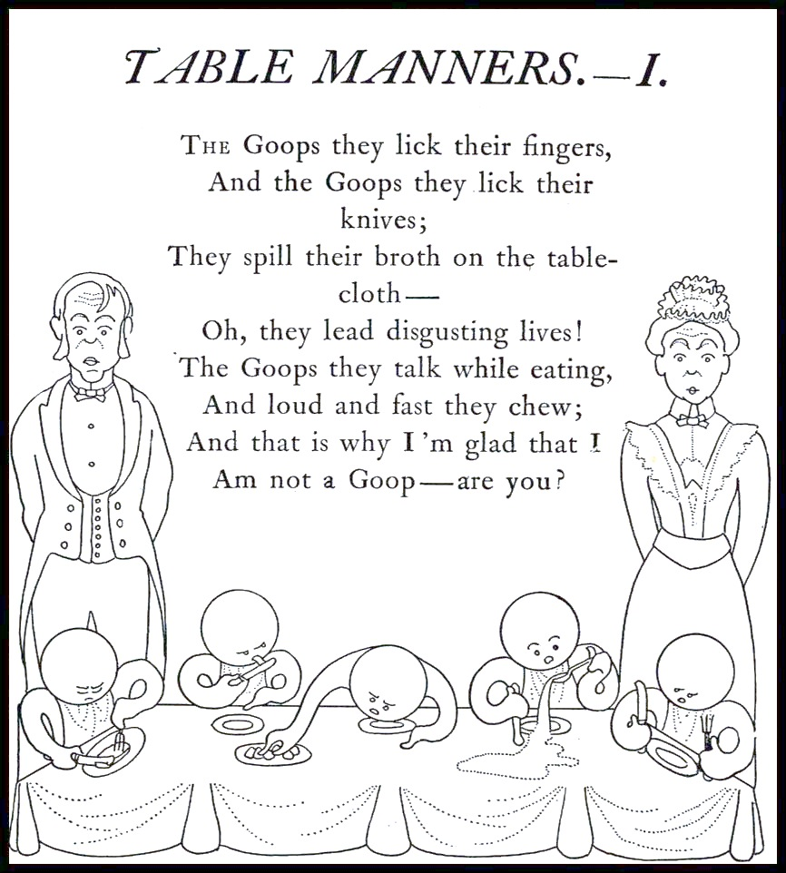

Source: "Table Manners" is reprinted from Goops and How To Be Them, Gelett Burgess. New York: Frederick A. Stokes, 1900.
Worksheet C: Websites for research
http://www.etiquettescholar.com/dining_etiquette/international_dining_etiquette.html

http://www.swissotel.com/promo/etiquette-map/ (see dining)

http://en.wikipedia.org/wiki/Table_manners

http://www.huffingtonpost.com/2013/07/11/dining-etiquette-around-the-world_n_3567015.html

http://www.inc.com/jeff-haden/a-global-traveler-guide-to-dining-etiquette.html

http://etiquette-ny.com/global-dining-etiquette-customs/

http://www.etiquettescholar.com/dining_etiquette/international_dining_etiquette.html

http://www.revbrown.net/etiquette/Global-Dining-Etiquette.html

http://www.kwintessential.co.uk/cultural-services/articles/cross-cultural-dining-etiquette.html

http://edition.cnn.com/2012/02/29/travel/international-food-etiquette-rules/

http://www.thedailymeal.com/table-manners-around-world-slideshow-2013

Worksheet D

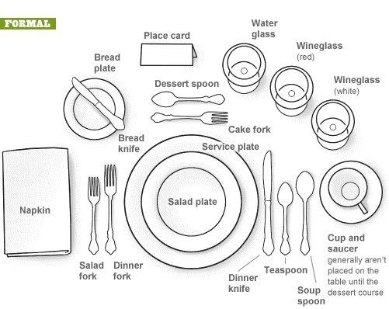

Source: http://www.cernea.net/wpcontent/uploads/2011/12/FormalDiningSetting_4eee9ff3477f1.gif

SECONDARY SCHOOL II: B2/C1 or 16-18

TABLE TALKS

“Dried dates change shape when they are soaked in milk, and carrots rich and strange turn magically sweet when deftly covered with green nutty shavings and smatterings of silver.” (Sara Suleri, Meatless Days)

Food is not only our way of inhabiting the world – where we eat it, who we eat it with, how we prepare it, and who we prepare it for – but it is also a mode of connecting with and relating to other people, of sharing memories and stories that permeate cultures all over the world.

Table talks is a form of classroom interaction where students gather around four tables and engage in lip-smacking and mouth-watering discussions about food consumption and production. The tables are thematically organized. The students take rounds in recounting and reflecting upon their own experiences gyrating around the kitchen as a space to be explored, inhabited and appropriated.

By telling stories and sharing memories about food consumption and production at home and around the world, the students become aware of the multifaceted realities that food can bring forth as a social, political and cultural constituent of identity formation. In linguistic terms they will increase their vocabulary on this topic and use it by telling stories, discussing literary and non-literary texts and sharing memories.

The four sections outlined below provide ideas for table talks associated with food consumption and food production from various places around the world. Prior to orchestrating this form of classroom interaction – mainly communicative and dialogical in principle – the students bring food items to class and appealingly arrange them on the tables. It is a kind of a potluck that makes participants come together, precisely because there is food to be gorged on and food to be discussed.

Table I: Food in Short Stories
Ben Okri (Nigeria): “The Mysterious Anxiety of Them and Us”
Pippa Goldschmidt (Scotland): “Potato Pancakes”

Table II: Food Poetry Lewis Carroll (England): “The Walrus and the Carpenter”
William Carlos Williams (America): “For Viola: De Gustibus”

Table III: Food in Novel
Sara Suleri (Pakistan): Meatless Days, Chapter “Meatless Days”

Table IV: Food Production and Food Chain
Jonathan Foers (America): Eating Animals, Chapter “Story Telling”

PROCEDURES

- The texts should be prepared beforehand. The short stories and poems are rather short (roughly 3-5 minutes of reading time) and can be found in Cooked Up: Food Fiction from Around the World or online (Okri’s text is also available as an audiophile), chapter 2 of Suleri’s autobiography and chapter 1 of Foer’s non-fiction book have to be ordered and copied out (20 minutes of reading time).
- For each table there are two tasks based upon the material at hand. The first task can be done without much preparation as it combines text-based moments and autobiographical memories. The second one requires additional research (internet).
- Rearrange the desks so that four to six students (depending on the size of the class) can gather around them and be seated comfortably.
- Place food items on the tables (students bring items to class based upon topics at hand) and arrange them pleasingly (table cloth, napkins, cutlery, candles etc.).
- Ask students to select and approach one desk and choose one item as a warm-up for a story revolving around this item (Prompt: Tell a story in the past and make sure you are part of it!).
- Divide the class into four groups. Each group chooses one table.
- For each task the students have about 20 minutes at their disposal. The students take turns in sharing their experiences and memories and ask questions as they feel fit.

MATERIAL
- Food items
- Decorating material for table talks
- Task sheets Table I-IV
- Appendix

READING LIST

Carroll, L. (1872). The Walrus and the Carpenter. Lewis Carroll. http://www.jabberwocky.com/carroll/walrus.html

Foer, J. S. (2009). Eating Animals, Chapter Storytelling (pp. 1-19). New York: Hachette Book Group.

Goldschmidt, P. (2015). Potato Pancakes. In E. Chiew (Hrsg.), Cooked UP: Food Fiction From Around the World (pp. 66-67). Oxford: New Internationalist.

Okri, B. (2015). The Mysterious Anxiety of Them and Us. In E. Chiew (Hrsg.), Cooked UP: Food Fiction From Around the World (pp. 9-10). Oxford: New Internationalist.

Okri, B. (Writer and Director) (2010). The Mysterious Anxiety of Them and Us. http://www.pen.org/book/ben-okri-reads-the-mysterious-anxiety-of-them-and-us

Suleri, S. (1989). Meatless Days, Chapter Meatless Days (pp. 18-32). Chicago: University of Chicago Press.

William, C.W. (1912). For Viola: De Gustibus. Poem Hunter. http://www.poemhunter.com/poem/for-viola-de-gustibus

MATERIAL FOR THE TEACHER
Table I: Food in short stories

Ben Okri: | “The Mysterious Anxiety of Them and Us”
 | The narrator recounts a seemingly uneventful episode associated with a lavish feast during which some of the attendees start eating while the others are waiting for no apparent reason. The ones who eat feel guilty.
 | Task I: Describe a feast which you have attended. What was the setting like, what kind of food was served, how did people get ready for it, what was the significance of this get-together for you and your family or friends? Recount what happened on this very day, yet this time from the perspective of a small child who happened to be there.
 | Task II: If you were to shoot a movie about this short story, what elements would you include and how would you interpret the ending when the narrator and his wife file out and walk off?
Pippa Goldschmidt: | “Potato Pancakes”
 | The narrator revisits her childhood days in which an elderly woman – nobody really knows where she came from – is remembered for her culinary skills. When the latter gets sick and is bed-ridden, the narrator brings her pancakes prepared with a bit of a twist.
 | Task I: Discuss the quote, “Food is a way of seeing and participating in the world.” Do you agree with this statement? How does the protagonist perceive the world and its inhabitants through the very food she tastes and eats? Do you associate certain food items with specific persons and if so, who are they? Next, recount an unforgettable episode – a “kitchen story” – you have experienced. If you are short of one, make one up and tell it as plausibly as you can.
 | Task II: Write down two of your favourite dishes (look up ingredients) and describe where you tasted them for the first time. Who prepared these dishes and how did this person prepare them? Tell your deskmate how one of the dishes gets prepared without naming the dish. The other person is supposed to find out what the dish is called. Switch roles.

Table II: Food Poetry

Lewis Carroll: | “The Walrus and the Carpenter”
 | Task I: In the first phase, summarize the poem in a couple of sentences. Would you agree with the claim that this poem merely represents different phases in the food chain? How does food get produced in your country (for instance, animal farming and vegetable production)?
 | The city of Saufigen has recently announced new plans to open an animal farm (mainly pigs) to boost, among other things, the city’s dire economic situation. It seeks to organize an information gathering where speakers can give vent to their opinions and reasoning.
Student A: you are against this project
Student B: you are for it
Student C: you represent one of the owners of the animal farm and describe your rationale why you wish to start a firm in Saufingen.
Student D: you take the role of a city representative.
Student E: you take the role of the host leading through the discussion

 | Tasks II: Oysters are considered to be a delicacy in many countries around the world. For some people oysters are simply a slimy blend of salty and gelatin-like pulp, while others praise them as being the epitome of culinary rarities and hence savor them in ritualistic ceremonies. What culinary rarities do you have in your country (trips, brain, tête de veau, snails, frog legs) and what time period and setting can they be traced back to?
William Carlos Williams: | “For Viola: De Gustibus”
 | Task I: Read the poem aloud and discuss who the poem was written for? How does Williams address his beloved and why, in your opinion, does he liken his beloved to food? Write a poem consisting of six lines in which you select one food staple and give it a feel of temporal art. The other students will have to find out what food item you beautified poetically.
 | Task II: Focus on the words caviar, herring, pimento and find out where these ingredients are part of culinary traditions. Do some research into these traditions and explain them to your deskmates.

Table III: Food in Novel

Sara Suleri: | Meatless Days, “Meatless Days” (2nd chapter)
 | Sara Suleri’s Meatless Days is an autobiographical narrative about the relationship between India and Pakistan in 1947. It orchestrates the different phases of political leadership resulting in the partition of Indian subcontinent. This chapter zeroes in on the Muslim festival of Eid and offers insights into different ways of preparing food. The protagonist learns that the dish she had formerly associated with “sweetbreads” turns out to be testicles. This revelation elicits memorable kitchen episodes and makes the reader understand the significance of food in a country deprived of meat for two days a week after the partition of India.
 | Task I: Read this chapter and discuss the quote, “Most of us have fond memories of food from our childhood. Whether it was our mom's homemade lasagna or a memorable chocolate birthday cake, food has a way of transporting us back to the past” (Homaro Cantu). How does Suleri transport the reader back to her past and what significance does food have for her life?
 | Task II: What food items have you once tasted and even liked, but could not trick yourself into eating now? What food items do you dislike and why? Write down two items and describe them to the others: how do they taste, what do they look like, when did you taste them for the first time etc.?

Table IV: Food Production and Food Chain
Jonathan Safran Foer: | Eating Animals, “Story Telling” (1st chapter)
 | The questions where does food come from and how do you make food choices on a daily basis? constitute the starting point for the author to gather lots of material on this topic. Intent upon informing his son of what ends up on a plate the author explores various venues of food production and takes the reader into the bleak machinery of animal farming.
 | Task I: What choices do you make when eating? What is important for you when it comes to having food on the plate? Let’s suppose you were to design a food plan for your school cafeteria that seeks to offer a well-balanced diet, what culinary and nutritional choices would you make? What does the term “healthy eating” entail? Make a group poster.
 | Task II: Based upon Foer’s research investigate how animals are treated in your own country. What laws does your country have to protect animals? Where does one find big farms with hundreds or thousands of animals (penned up, free range, organic, factory farming, etc.)? Describe one day in the life of a cow, pig, horse in your own country? Then, find out how these animals get butchered and how the meat gets processed.

Appendix

Lewis Carroll
“The Walrus and the Carpenter”
The sun was shining on the sea,
Shining with all his might:
He did his very best to make
The billows smooth and bright--
And this was odd, because it was
The middle of the night.
The moon was shining sulkily,
Because she thought the sun
Had got no business to be there
After the day was done--
"It's very rude of him," she said,
"To come and spoil the fun!"
The sea was wet as wet could be,
The sands were dry as dry.
You could not see a cloud, because
No cloud was in the sky:
No birds were flying overhead--
There were no birds to fly.
The Walrus and the Carpenter
Were walking close at hand;
They wept like anything to see
Such quantities of sand:
"If this were only cleared away,"
They said, "it would be grand!"
"If seven maids with seven mops
Swept it for half a year.
Do you suppose," the Walrus said,
"That they could get it clear?"
"I doubt it," said the Carpenter,
And shed a bitter tear.
"O Oysters, come and walk with us!"
The Walrus did beseech.
"A pleasant walk, a pleasant talk,
Along the briny beach:
We cannot do with more than four,
To give a hand to each."
The eldest Oyster looked at him,
But never a word he said:
The eldest Oyster winked his eye,
And shook his heavy head--
Meaning to say he did not choose
To leave the oyster-bed.
But four young Oysters hurried up,
All eager for the treat:
Their coats were brushed, their faces washed,
Their shoes were clean and neat--
And this was odd, because, you know,
They hadn't any feet.
Four other Oysters followed them,
And yet another four;
And thick and fast they came at last,
And more, and more, and more--
All hopping through the frothy waves,
And scrambling to the shore.
The Walrus and the Carpenter
Walked on a mile or so,
And then they rested on a rock
Conveniently low:
And all the little Oysters stood
And waited in a row.
"The time has come," the Walrus said,
"To talk of many things:
Of shoes--and ships--and sealing-wax--
Of cabbages--and kings--
And why the sea is boiling hot--
And whether pigs have wings."
"But wait a bit," the Oysters cried,
"Before we have our chat;
For some of us are out of breath,
And all of us are fat!"
"No hurry!" said the Carpenter.
They thanked him much for that.
"A loaf of bread," the Walrus said,
"Is what we chiefly need:
Pepper and vinegar besides
Are very good indeed--
Now if you're ready, Oysters dear,
We can begin to feed."
"But not on us!" the Oysters cried,
Turning a little blue.
"After such kindness, that would be
A dismal thing to do!"
"The night is fine," the Walrus said.
"Do you admire the view?
"It was so kind of you to come!
And you are very nice!"
The Carpenter said nothing but
"Cut us another slice:
I wish you were not quite so deaf--
I've had to ask you twice!"
"It seems a shame," the Walrus said,
"To play them such a trick,
After we've brought them out so far,
And made them trot so quick!"
The Carpenter said nothing but
"The butter's spread too thick!"
"I weep for you," the Walrus said:
"I deeply sympathize."
With sobs and tears he sorted out
Those of the largest size,
Holding his pocket-handkerchief
Before his streaming eyes.
"O Oysters," said the Carpenter,
"You've had a pleasant run!
Shall we be trotting home again?'
But answer came there none--
And this was scarcely odd, because
They'd eaten every one.

William Carlos Williams
“De Gustibus”

Beloved you are
Caviar of Caviar
Of all I love you best
O my Japanese bird nest
No herring from Norway
Can touch you for flavor. Nay
Pimento itself
is flat as an empty shelf
When compared to your piquancy
O quince of my despondency.

Ausführliche Informationen zu den Vor- und Nachteilen von CLIL finden sich z.B. in Massler & Stotz (2013), Naves (2002), Niemeier (2000).
Auf alle aufgeführten Links wurde am 07.04.2015 zum letzten Mal zugegriffen.
Highlight that the complexity of table manners in the family does not converge with national stereotypes.

