MANUAL- Making your own instrument

DRUM
Word list:
can Dose
template Schablone
tape Klebeband
sticks Stäbchen
cotton wool Watte
crayons Farbstifte
cord Schnur
You need:
- An empty and clean can
- 1 template
- 1 piece of thick paper
- tape
- scissors
- 2 sticks
- cotton wool
- 2 rubber bands
- crayons

You have to:
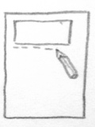
- Take the template and draw it once on the piece of paper.
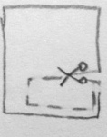
- Take the scissors and cut it out.

- Now you can draw something on it.
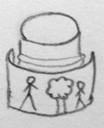
- Take the paper and stick it around the can with tape. Pay attention: The bottom of the can should be on the top.

- Take the stick and put some cotton wool around the bigger end.

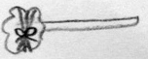
- Fix the cotton wool with a rubber band.

- Do the same with the other stick.

Well done! Your drum is ready!

