Language focus: Where? Here!

a) Describe the following pictures.
e.g.
Write it _____________ .
Write it on the paper. or Write it on the sheet. or Write it on the blank paper.

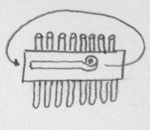

1. Take the other cardboard and put it _______ the cardboard with the straws.
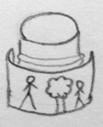

2. Take the paper and stick it _________ the can with tape.
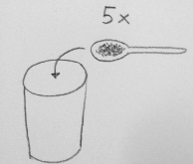

3. Take 5 spoons of sand and put them _______ the yogurt cup.

b) Describe these pictures.
- Where is the ball?
The ball is ______________.

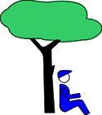
- Where is the boy?
_____________________________________

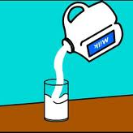
- Where is the milk?
_____________________________________

- _____________________________________

- _________________________________________

