Language focus exercises: Silly rules

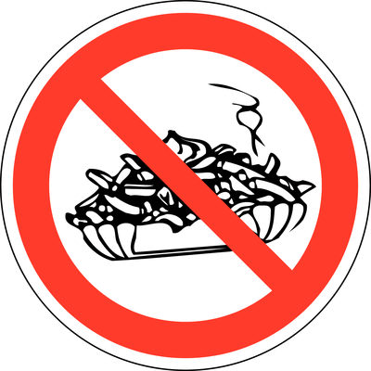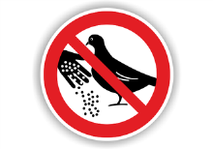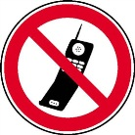

Write a sentence for the 3 red signs:

Create 3 new red signs as pictures; give them to your partner. Can he/she work out what they say?

Choose the right verb:

a) must b) mustn't c) are allowed to d)are not allowed to

- In a library you..............................shout
- At school you ....................... play football on the playground
- You ..................... look before you cross the road
- You .................... travel in the bus without a ticket
- You ..................... clean your teeth every day
- In the cinema you ....................... eat popcorn
- People ........................ swim in the lake in the summer
- It's a fantastic movie! You ........................ see it!
- To save energy you ....................... turn the lights off when you leave
- To get good marks some people ..................... work very hard

